Практическая работа

Тема: Messanger

Ход работы:

Программный код activity_main:

<?xml version="1.0" encoding="utf-8"?>  
<androidx.constraintlayout.widget.ConstraintLayout xmlns:android="http://schemas.android.com/apk/res/android"  
 xmlns:app="http://schemas.android.com/apk/res-auto"  
 xmlns:tools="http://schemas.android.com/tools"  
 android:layout_width="match_parent"  
 android:layout_height="match_parent"  
 android:background="@color/design_default_color_secondary"  
 android:backgroundTint="#3FC1AD"  
 tools:context=".MainActivity">  
  
 <ImageButton  
 android:id="@+id/imageButton"  
 android:layout_width="wrap_content"  
 android:layout_height="wrap_content"  
 android:onClick="onClick"  
 app:layout_constraintEnd_toEndOf="parent"  
 app:layout_constraintStart_toStartOf="parent"  
 app:layout_constraintTop_toBottomOf="@+id/editText"  
 app:srcCompat="@drawable/pinkhellokitty" />  
  
 <TextView  
 android:id="@+id/textView"  
 android:layout_width="wrap_content"  
 android:layout_height="wrap_content"  
 android:textAppearance="@style/TextAppearance.AppCompat.Display1"  
 app:layout_constraintBottom_toBottomOf="parent"  
 android:text="@string/Имя"  
 app:layout_constraintEnd_toEndOf="parent"  
 app:layout_constraintStart_toStartOf="parent"  
 app:layout_constraintTop_toBottomOf="@+id/imageButton" />  
  
 <EditText  
 android:id="@+id/editText"  
 android:layout_width="411dp"  
 android:layout_height="wrap_content"  
 android:ems="10"  
 android:importantForAutofill="no"  
 android:inputType="text"  
 android:visibility="visible"  
 app:layout_constraintEnd_toEndOf="parent"  
 app:layout_constraintStart_toStartOf="parent"  
 app:layout_constraintTop_toTopOf="parent" />  
</androidx.constraintlayout.widget.ConstraintLayout>

Программный код MainActivity:

package com.example.hellokitty;  
  
import android.os.Bundle;  
import android.view.View;  
import android.widget.EditText;  
import android.widget.TextView;  
  
import androidx.appcompat.app.AppCompatActivity;  
  
public class MainActivity extends AppCompatActivity {  
  
 private TextView mHelloTextView;  
 private EditText mNameEditText;  
  
 @Override  
 protected void onCreate(Bundle savedInstanceState) {  
 super.onCreate(savedInstanceState);  
 setContentView(R.layout.activity_main);  
  
 mHelloTextView = findViewById(R.id.textView);  
 mNameEditText = findViewById(R.id.editText);  
 }  
  
 public void onClick(View view) {  
 if (mNameEditText.getText().length() == 0) {  
 mHelloTextView.setText("Hello Kitty!");  
 } else {  
 mHelloTextView.setText("Привет, " + mNameEditText.getText());  
 }  
 }  
}

Программный код strings:

<resources>  
 <string name="app_name">Hello Kitty</string>  
 <string name="Имя">Имя кота</string>  
</resources>

Макет:

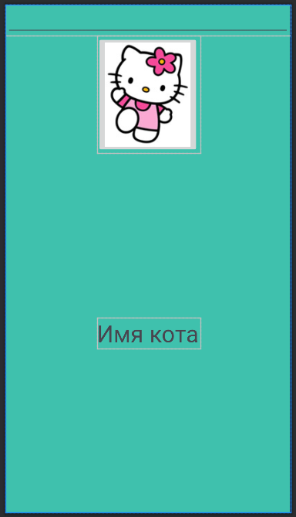

Протокол:

